# **IST769 Homework Submission**

Name: **Sathish Kumar Rajendiran**   
SUID: **666555028**  
Email: srajendi@syr.edu  
Date Due: **08/03/2021**

Date Due: **Performance, Security, NoSQL**

Homework #:**4**

**Exercise(s):**

1. **Create a non-clustered index on the timesheets table in the demo database. The index you create should be designed to improve the following query:**

select employee_id, employee_firstname, employee_lastname, sum(timesheet_hourlyrate*timesheet_hours)

from timesheets

group by employee_id, employee_firstname, employee_lastname

**Solution:**

----Pre-setup command

----Use [fudgemart_v3]

----Go

----select * into demo.dbo.timesheets

----from fudgemart_employees join fudgemart_employee_timesheets

----on employee_id = timesheet_employee_id

----Go

USE [demo]

GO

SET STATISTICS TIME ON

SET STATISTICS IO ON

GO

--before Index creation

declare @startTime datetime2

declare @endTime datetime2

set @startTime = getdate()

select employee_id, employee_firstname, employee_lastname,

sum(timesheet_hourlyrate*timesheet_hours) as wages

from timesheets

group by employee_id, employee_firstname, employee_lastname

set @endTime = getdate()

---total execution time in milliseconds

select datediff(millisecond,@startTime,@endTime) as execTime

GO

SET STATISTICS TIME OFF

SET STATISTICS IO OFF

GO

---- Find an existing index named IX_Timesheets_EmployeeID_Name_Hours_Rate and delete it if found.

IF EXISTS (SELECT name FROM sys.indexes

WHERE name = N'IX_Timesheets_EmployeeID_Name_Hours_Rate')

DROP INDEX IX_Timesheets_EmployeeID_Name_Hours_Rate ON dbo.timesheets;

GO

-- Create a nonclustered index called IX_Timesheets_EmployeeID_Name_Hours_Rate

-- on the dbo.timesheets table using the employee_id, employee_firstname,employee_lastname,timesheet_hourlyrate,timesheet_hours columns.

CREATE NONCLUSTERED INDEX IX_Timesheets_EmployeeID_Name_Hours_Rate

ON dbo.timesheets (employee_id)

INCLUDE (employee_firstname, employee_lastname,timesheet_hourlyrate,timesheet_hours)

GO

SET STATISTICS TIME ON

SET STATISTICS IO ON

GO

--after Index creation

declare @startTime datetime2

declare @endTime datetime2

set @startTime = getdate()

select employee_id, employee_firstname, employee_lastname,

sum(timesheet_hourlyrate*timesheet_hours) as wages

from timesheets

group by employee_id, employee_firstname, employee_lastname

set @endTime = getdate()

---total execution time in milliseconds

select datediff(millisecond,@startTime,@endTime) as execTime

GO

SET STATISTICS TIME OFF

SET STATISTICS IO OFF

GO

**Evidence:**

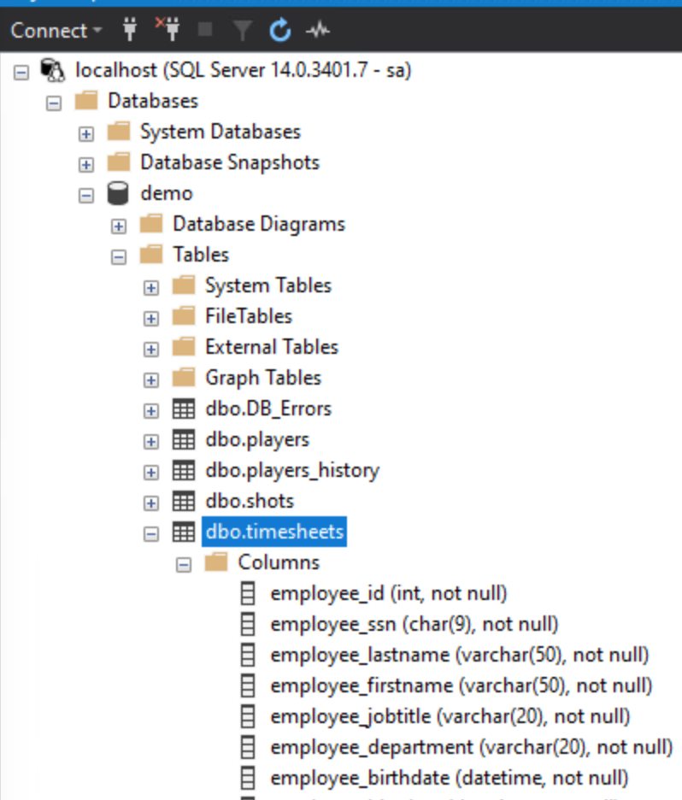

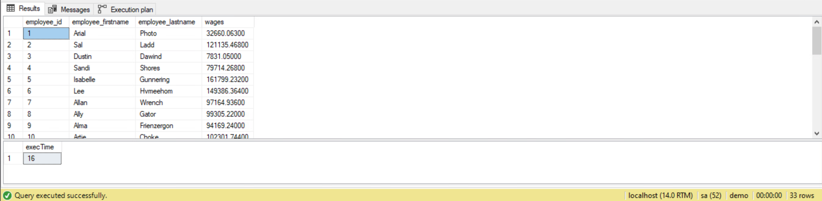

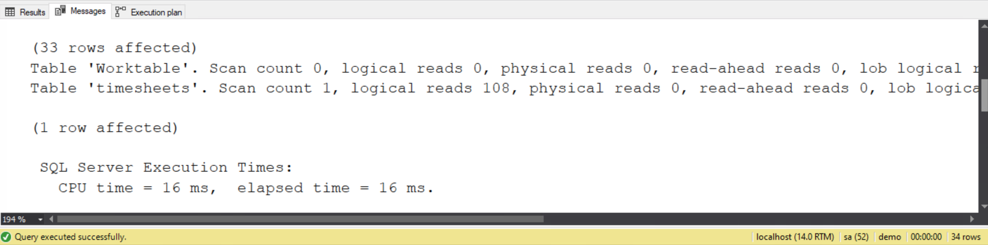

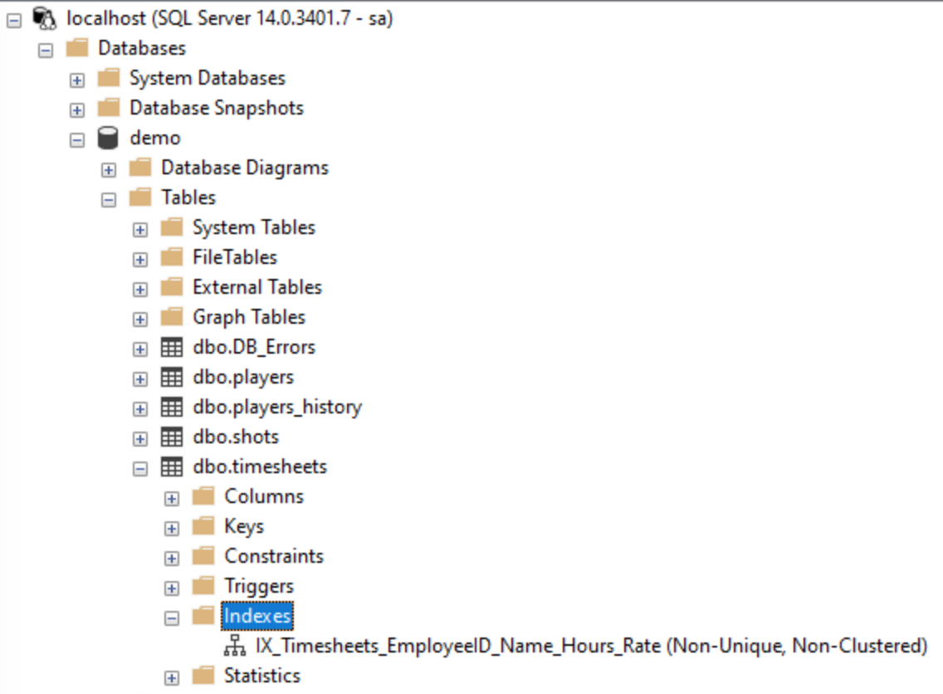

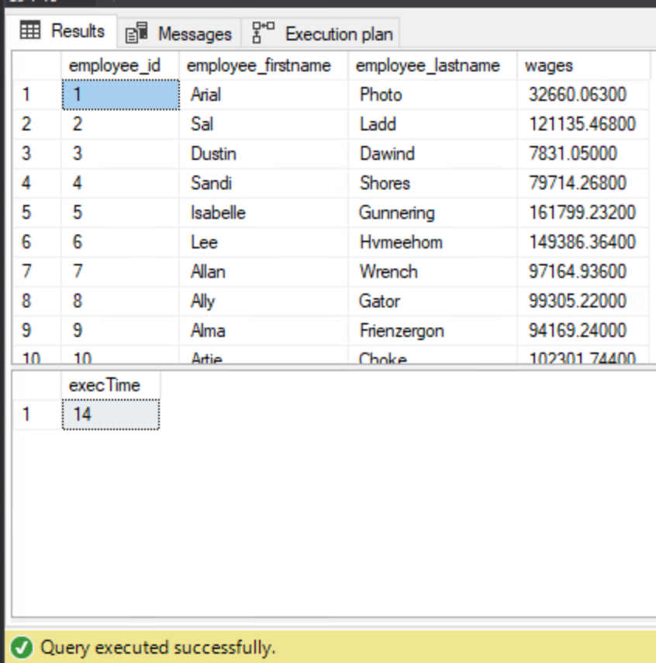

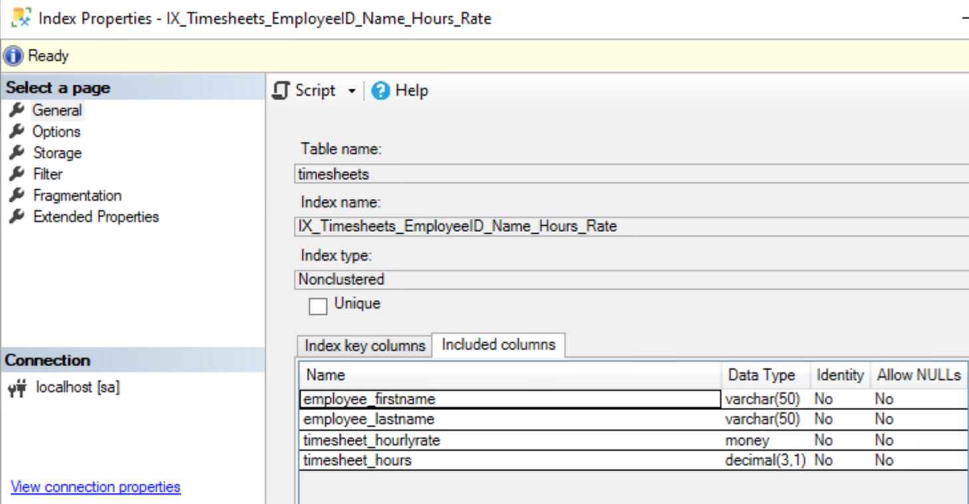

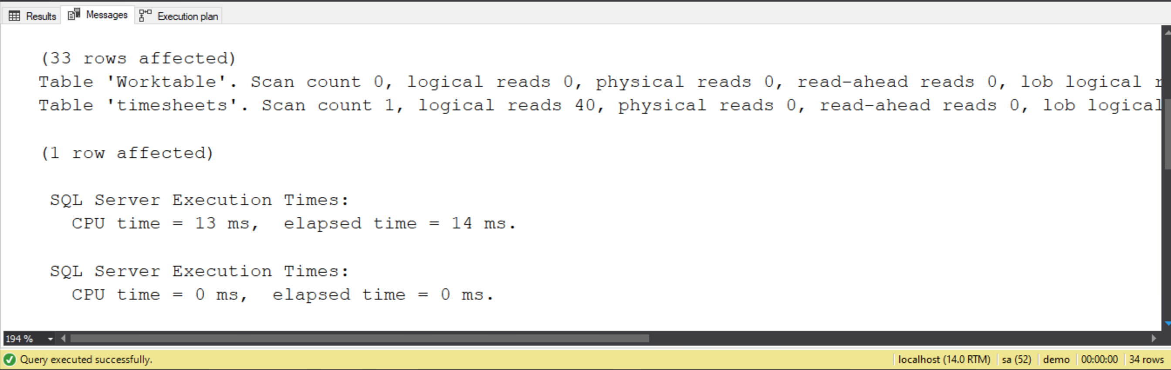

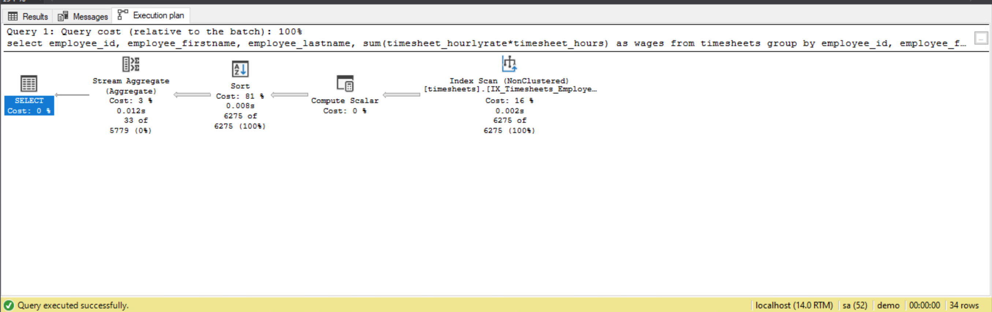

1. **Write an SQL Select query which uses the index you created in the first question but does an index seek instead of an index scan.**

**Solution:**

SET STATISTICS TIME ON

SET STATISTICS IO ON

GO

--after Index creation

declare @startTime datetime2

declare @endTime datetime2

--declare @maxemployeeID int

set @startTime = getdate()

--select @maxemployeeID = max(employee_id) from dbo.timesheets

select employee_id, employee_firstname, employee_lastname,

sum(timesheet_hourlyrate*timesheet_hours) as wages

from timesheets

where employee_id < 50

--where employee_id < ( select max(employee_id) from dbo.timesheets)

--where employee_id < @maxemployeeID

group by employee_id, employee_firstname, employee_lastname

set @endTime = getdate()

---total execution time in milliseconds

select datediff(millisecond,@startTime,@endTime) as execTime

GO

SET STATISTICS TIME OFF

SET STATISTICS IO OFF

GO

**Evidence:**

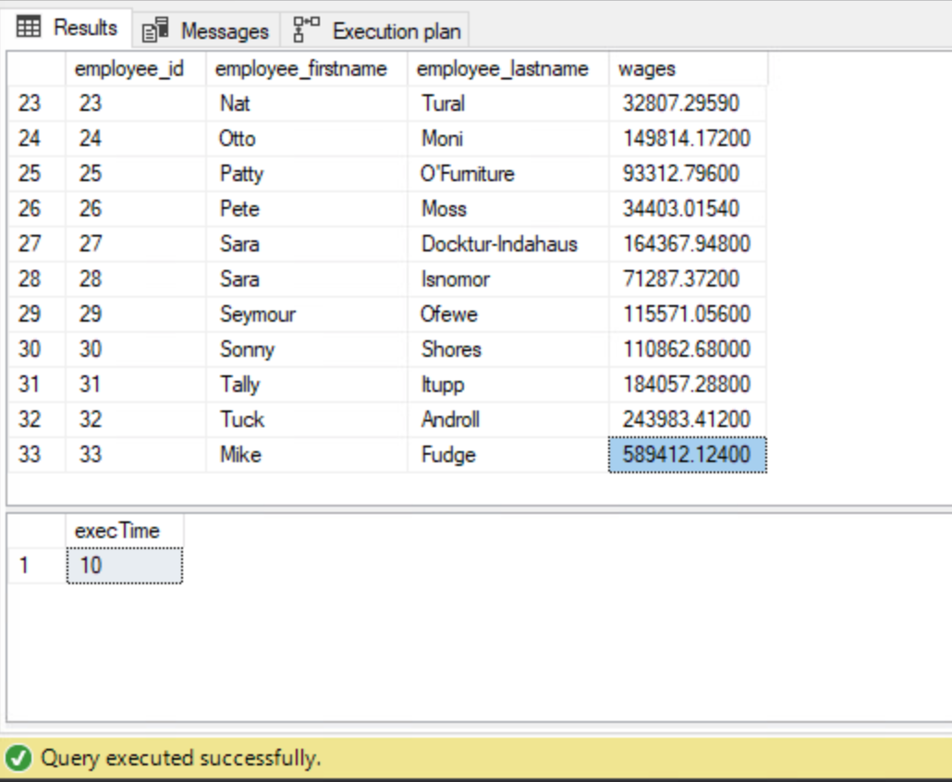

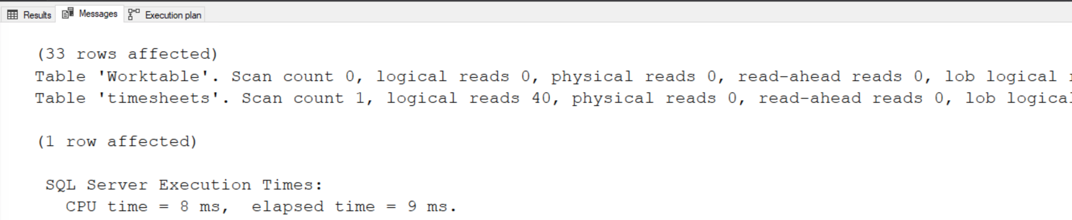

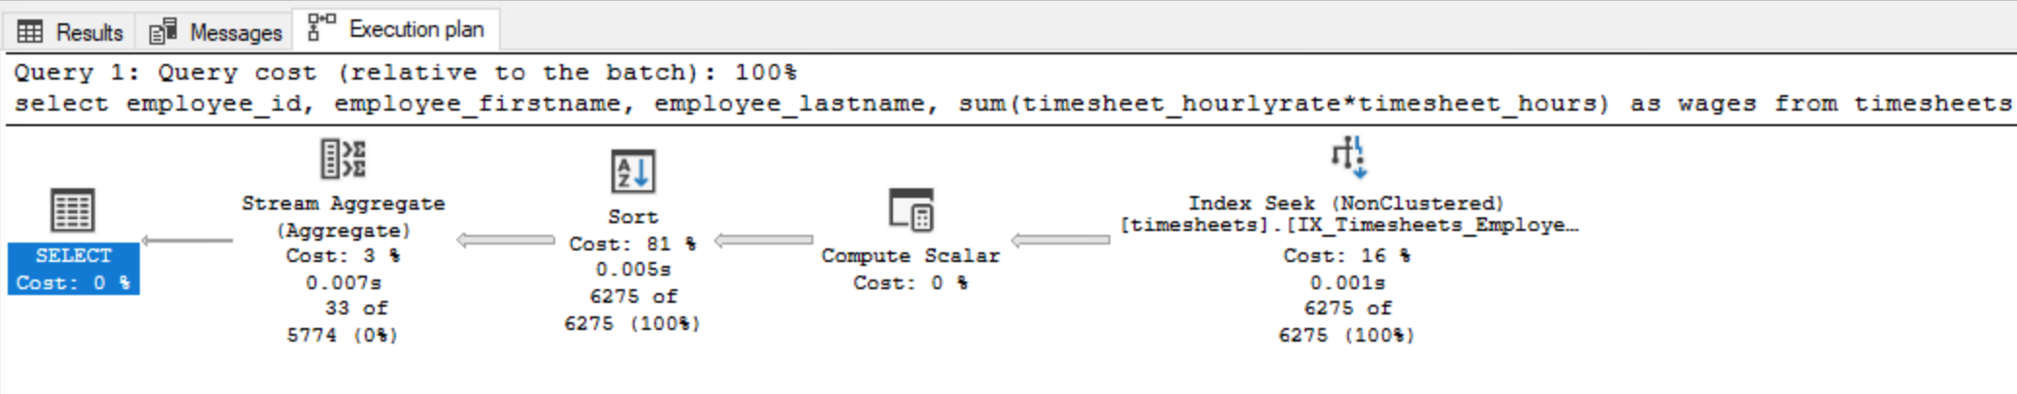

1. **Create a single columnstore index on the timesheets table in the demo database which will improve the following queries:**

select employee_department, sum(timesheet_hours)

from timesheets group by employee_department

select employee_jobtitle, avg(timesheet_hourlyrate)

from timesheets group by employee_jobtitle

**Solution:**

*/

SET STATISTICS TIME ON

SET STATISTICS IO ON

GO

--before Index creation

declare @startTime datetime2

declare @endTime datetime2

set @startTime = getdate()

select employee_department

, sum(timesheet_hours) agg_timesheet_hours

from timesheets

group by employee_department

set @endTime = getdate()

---total execution time in milliseconds

select datediff(millisecond,@startTime,@endTime) as execTime

GO

SET STATISTICS TIME OFF

SET STATISTICS IO OFF

GO

---- Find an existing index named IX_CLM_Timesheets_Employee_Department_Hours

---- and delete it if found.

IF EXISTS (SELECT name FROM sys.indexes

WHERE name = N'IX_CLM_Timesheets')

DROP INDEX IX_CLM_Timesheets ON dbo.timesheets;

GO

-- Create a nonclustered COLUMNSTORE index called IX_CLM_Timesheets

-- on the dbo.timesheets table using the employee_id, employee_department,timesheet_hours,timesheet_hourlyrate,timesheet_hours columns.

CREATE NONCLUSTERED COLUMNSTORE INDEX IX_CLM_Timesheets

ON dbo.timesheets(employee_department,timesheet_hours)

GO

SET STATISTICS TIME ON

SET STATISTICS IO ON

GO

--after Index creation

declare @startTime datetime2

declare @endTime datetime2

set @startTime = getdate()

select employee_department

, sum(timesheet_hours) agg_timesheet_hours

from timesheets

group by employee_department

set @endTime = getdate()

---total execution time in milliseconds

select datediff(millisecond,@startTime,@endTime) as execTime

GO

SET STATISTICS TIME OFF

SET STATISTICS IO OFF

GO

/********************************************************/

SET STATISTICS TIME ON

SET STATISTICS IO ON

GO

--before Index creation

declare @startTime datetime2

declare @endTime datetime2

set @startTime = getdate()

select employee_jobtitle

, avg(timesheet_hourlyrate) avg_hourlyrate

from timesheets

group by employee_jobtitle

set @endTime = getdate()

---total execution time in milliseconds

select datediff(millisecond,@startTime,@endTime) as execTime

GO

SET STATISTICS TIME OFF

SET STATISTICS IO OFF

GO

IF EXISTS (SELECT name FROM sys.indexes

WHERE name = N'IX_CLM_Timesheets')

DROP INDEX IX_CLM_Timesheets ON dbo.timesheets;

GO

-- Create a nonclustered COLUMNSTORE index called IX_CLM_Timesheets

-- on the dbo.timesheets table using the employee_id, employee_department,timesheet_hours,timesheet_hourlyrate,timesheet_hours columns.

CREATE NONCLUSTERED COLUMNSTORE INDEX IX_CLM_Timesheets

ON dbo.timesheets(employee_department,timesheet_hours,employee_jobtitle,timesheet_hourlyrate)

GO

SET STATISTICS TIME ON

SET STATISTICS IO ON

GO

--after Index creation

declare @startTime datetime2

declare @endTime datetime2

set @startTime = getdate()

select employee_jobtitle

, avg(timesheet_hourlyrate) avg_hourlyrate

from timesheets

group by employee_jobtitle

set @endTime = getdate()

---total execution time in milliseconds

select datediff(millisecond,@startTime,@endTime) as execTime

GO

SET STATISTICS TIME OFF

SET STATISTICS IO OFF

GO

**Evidence:**

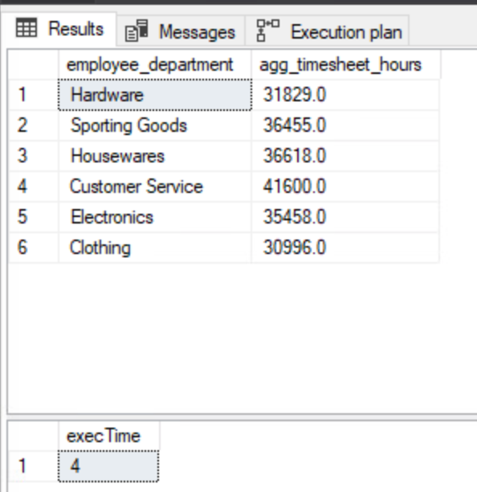

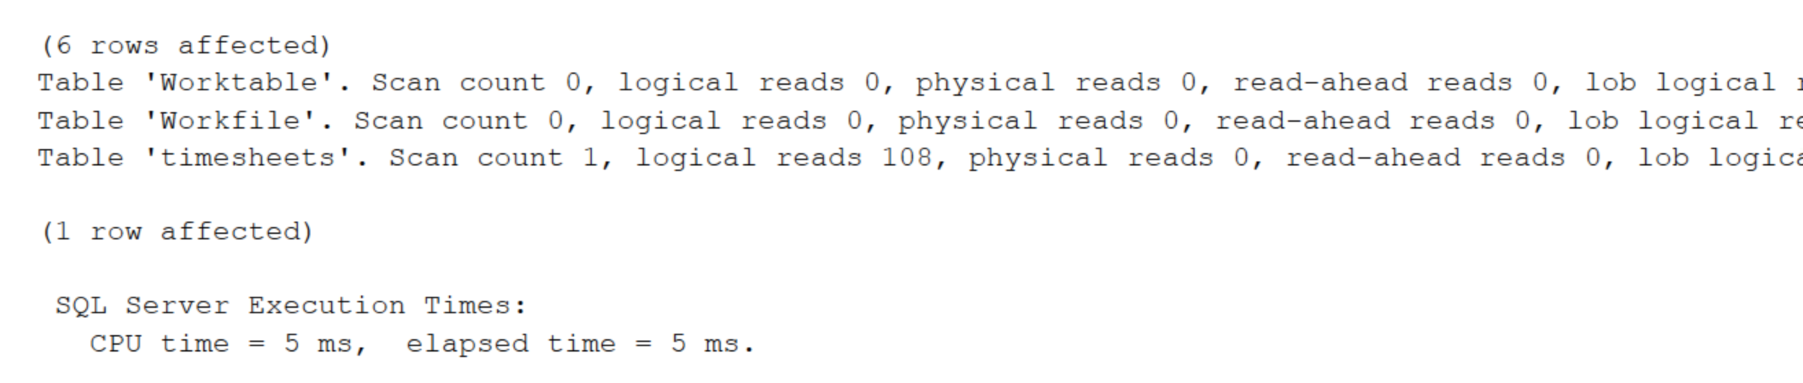

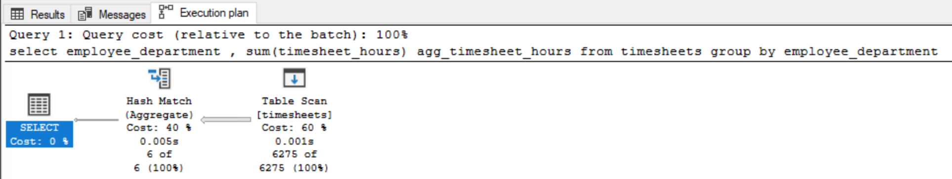

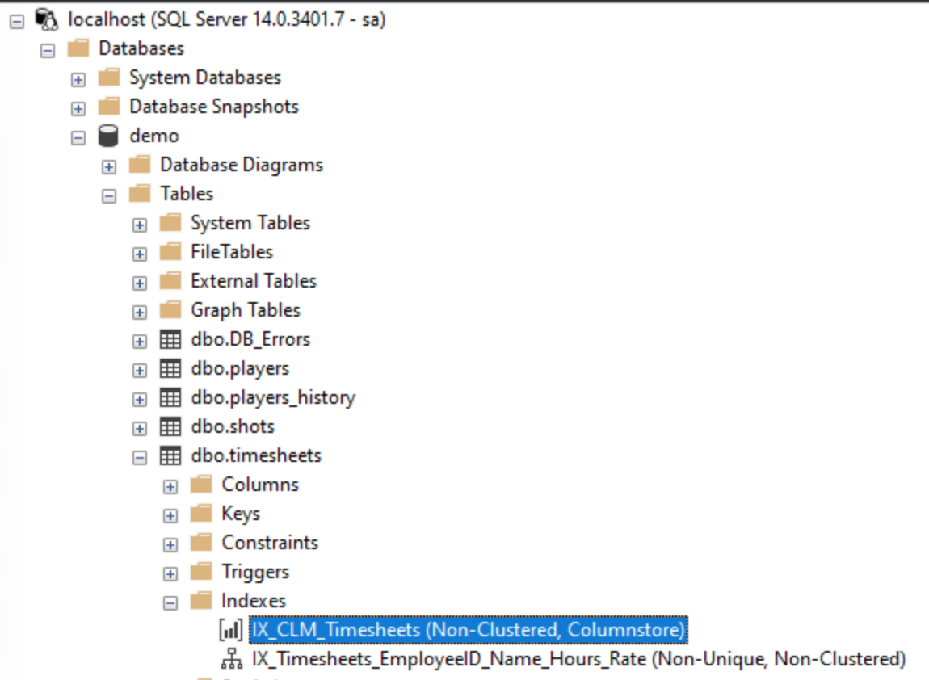

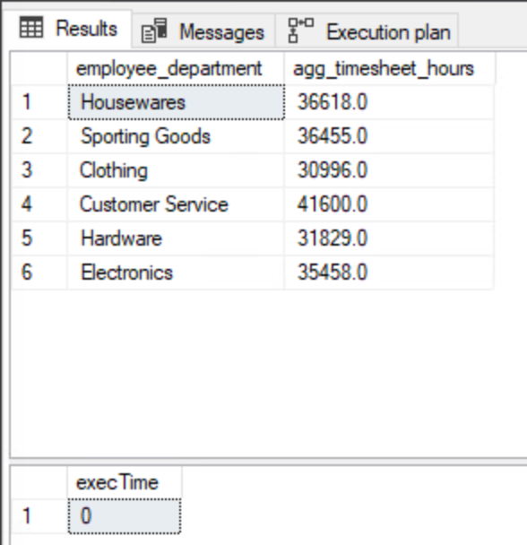

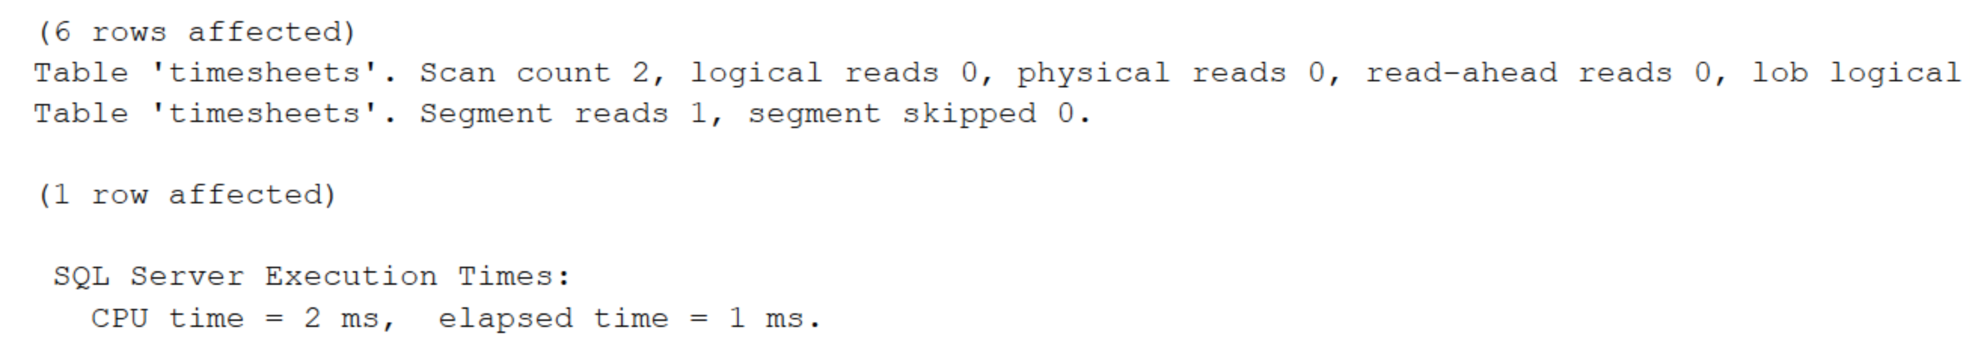

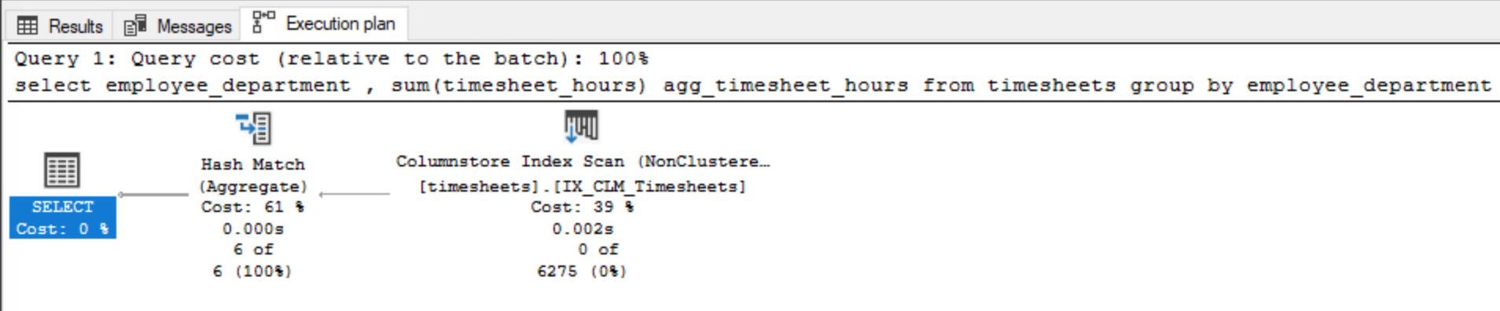

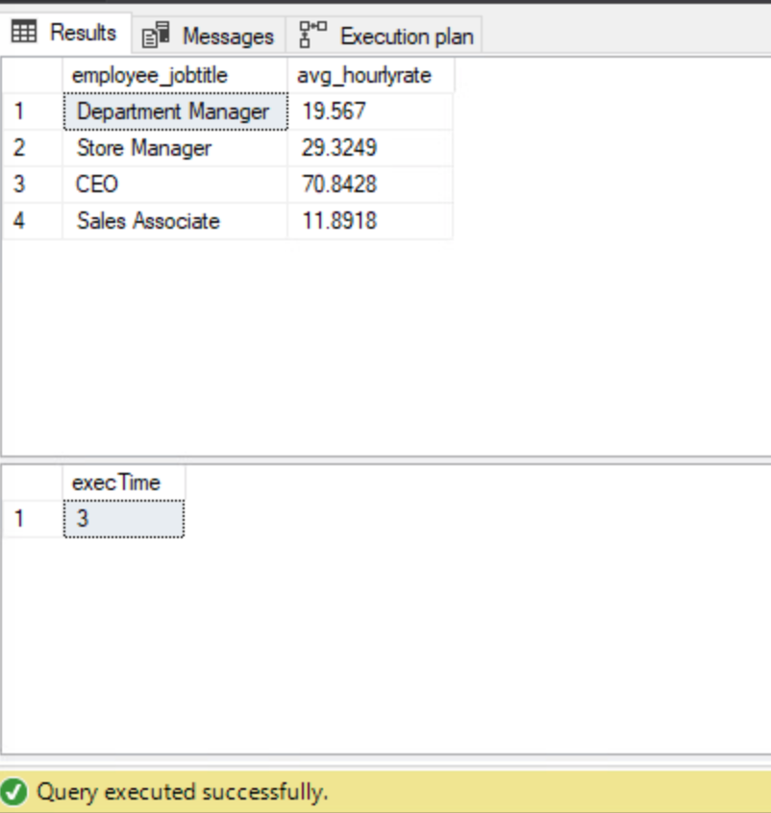

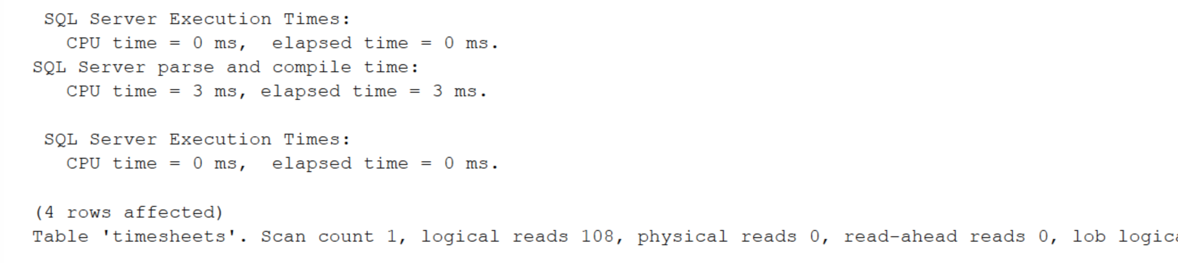

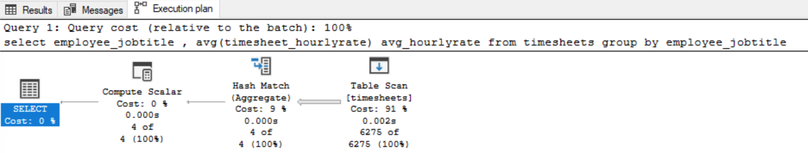

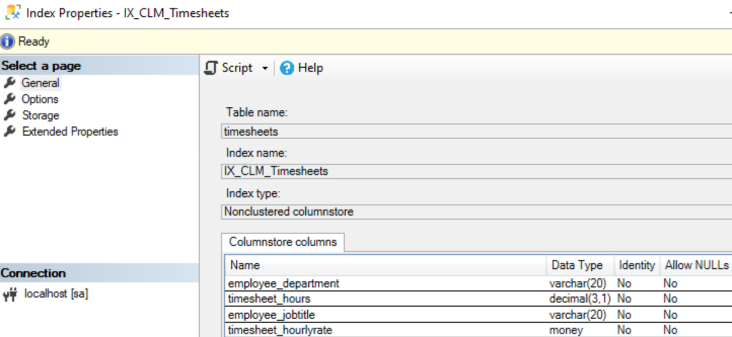

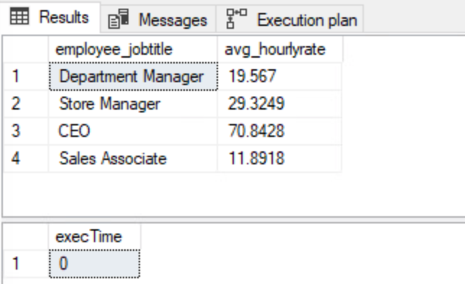

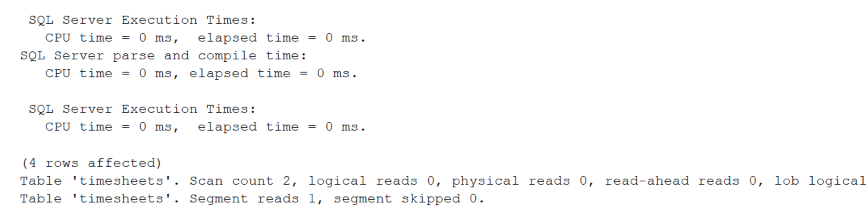

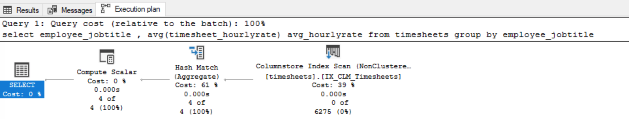

1. **Create an indexed view named v_employees on the timesheets table in the demo database which lists the employee id, first name, last name, job title, and department columns values and one row per employee (essentially re-building the employee table). Then set a unique clustered index on the view and finish by writing an SQL Select query which uses the indexed view.**

**Solution:**

IF EXISTS (SELECT * FROM INFORMATION_SCHEMA.VIEWS WHERE TABLE_NAME='v_employees')

BEGIN

DROP VIEW v_employees

END

GO

CREATE VIEW v_employees WITH schemabinding

AS

SELECT employee_id

, employee_firstname

, employee_lastname

, employee_jobtitle

, employee_department

, COUNT_BIG(*) as employee_count

from dbo.timesheets

Group by

employee_id

, employee_firstname

, employee_lastname

, employee_jobtitle

, employee_department

GO

--before index creation

SELECT * FROM dbo.v_employees

GO

IF EXISTS (SELECT name FROM sys.indexes

WHERE name ='IX_CLS_v_employees_EmployeeID')

DROP INDEX IX_CLS_v_employees_EmployeeID ON dbo.v_employees;

GO

-- Create an unique clustered index called IX_CLS_v_employees_EmployeeID

-- on the dbo.v_employees table using the employee_id

CREATE UNIQUE CLUSTERED INDEX IX_CLS_v_employees_EmployeeID

ON dbo.v_employees(employee_id)

GO

--query from the view after index creation

SELECT * FROM dbo.v_employees

GO

**Evidence:**

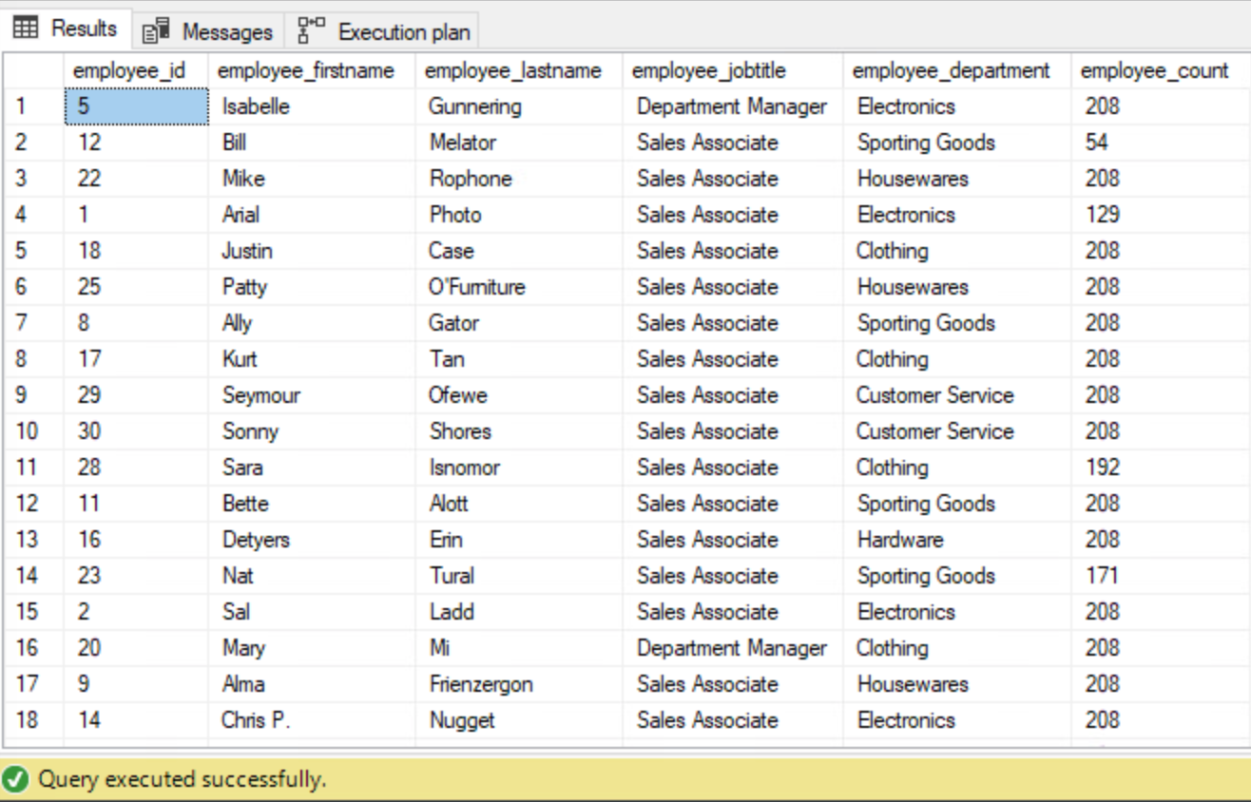

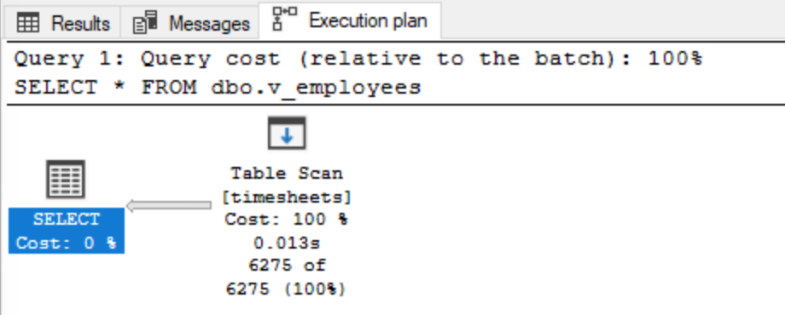

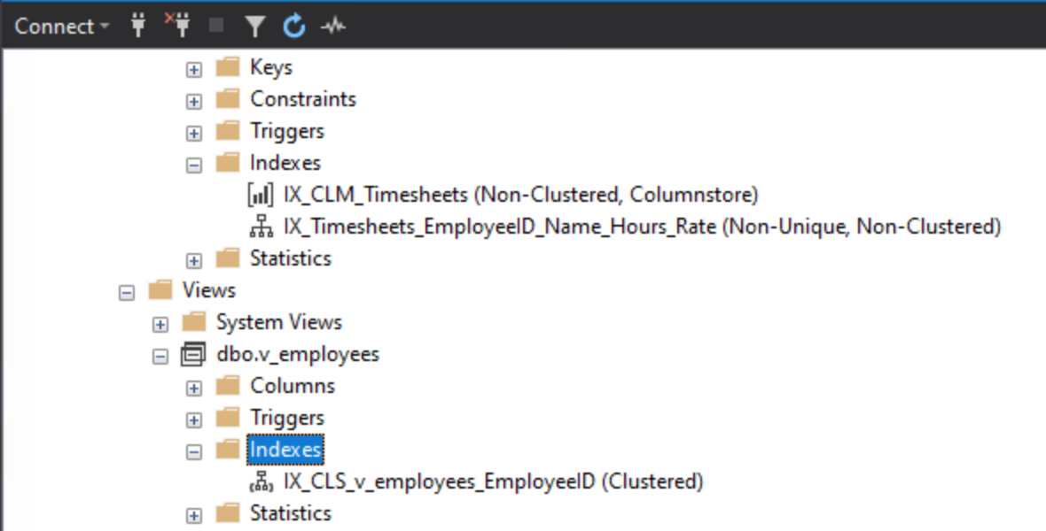

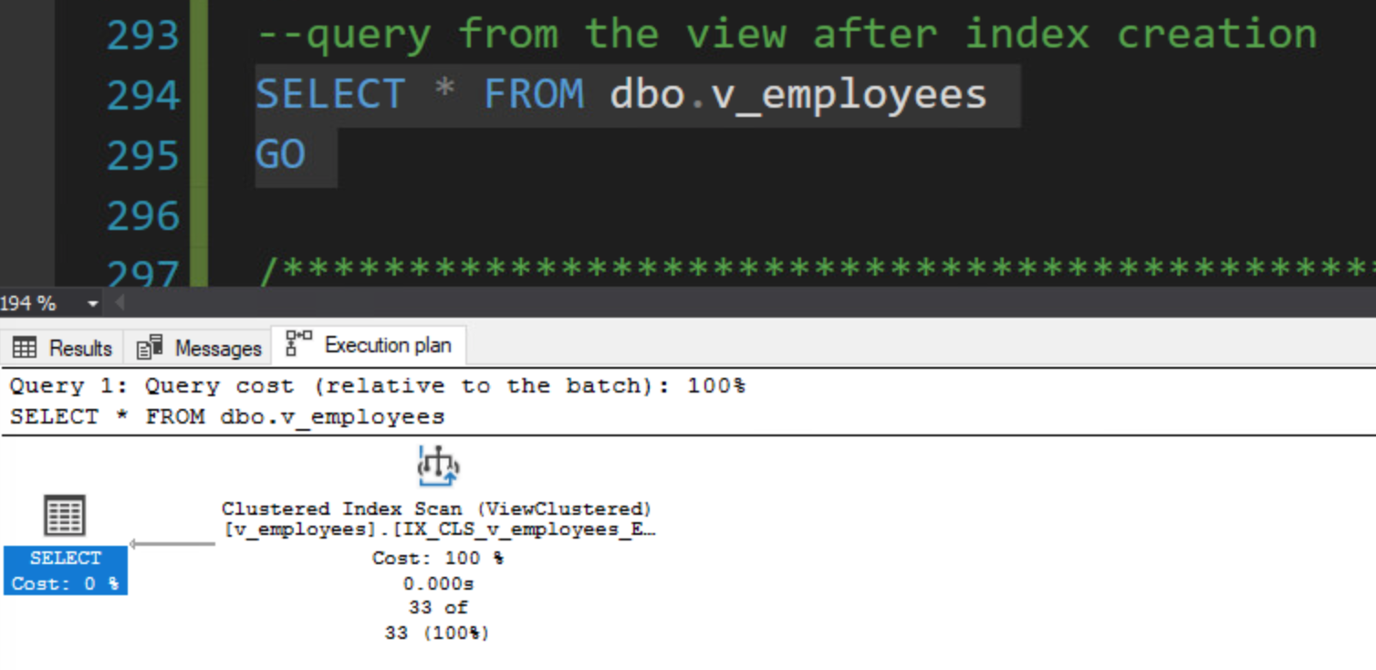

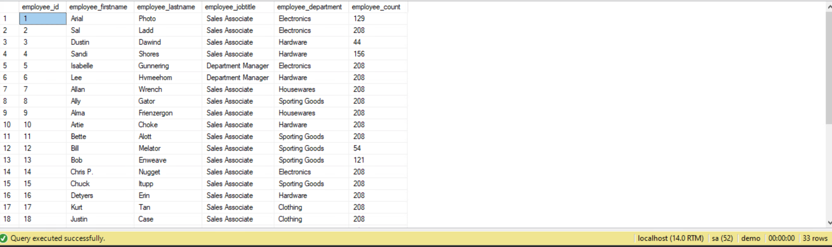

1. **Output the following query in JSON format: Display the employee id, first name, last name, count of timesheets, total hours worked, and average timesheet hourly rate.**

**Solution:**

--SQL statement with NOSQL Output

select

employee_id

, employee_firstname , employee_lastname

, count(*) as timesheet_count

, sum(timesheet_hours) as total_hours_worked

, AVG(timesheet_hourlyrate) as avg_timesheet_rate

from timesheets

group by

employee_id

, employee_firstname

, employee_lastname

FOR JSON AUTO

GO

**Evidence:**

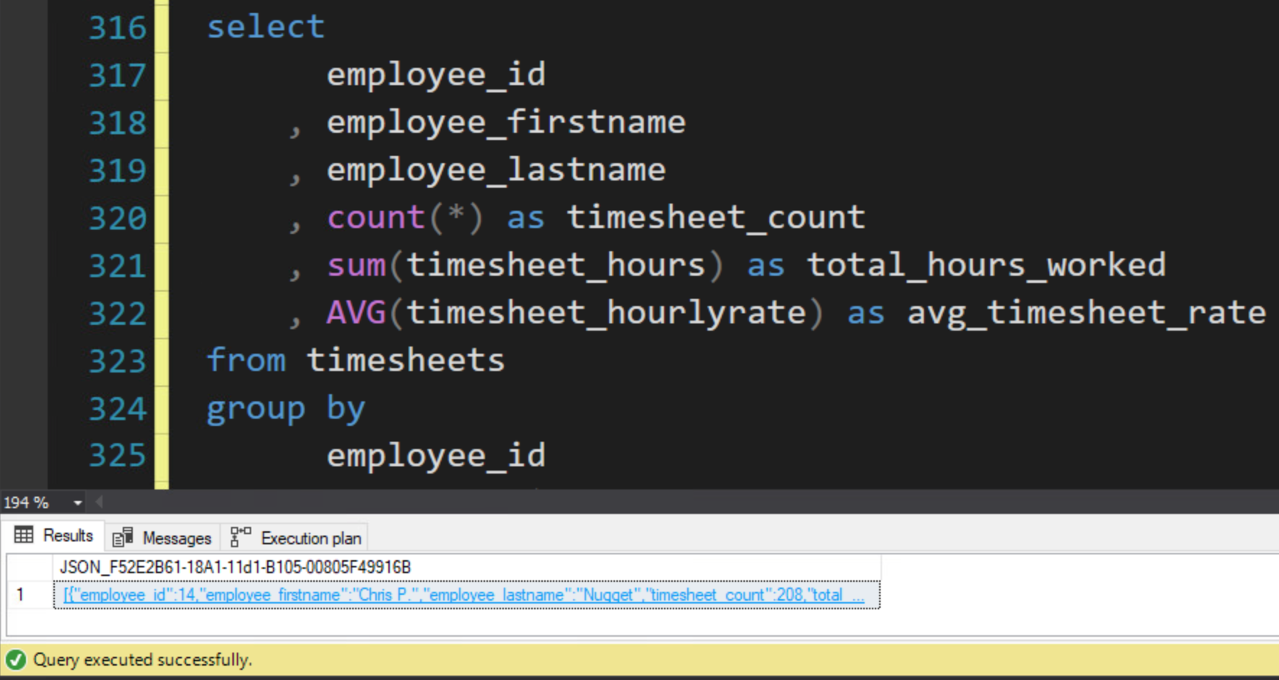

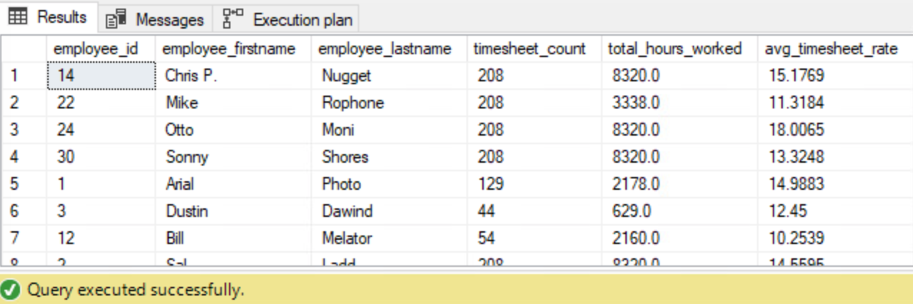

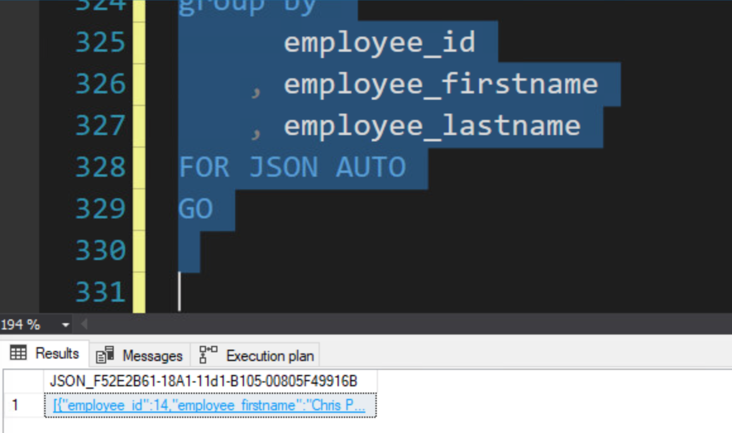

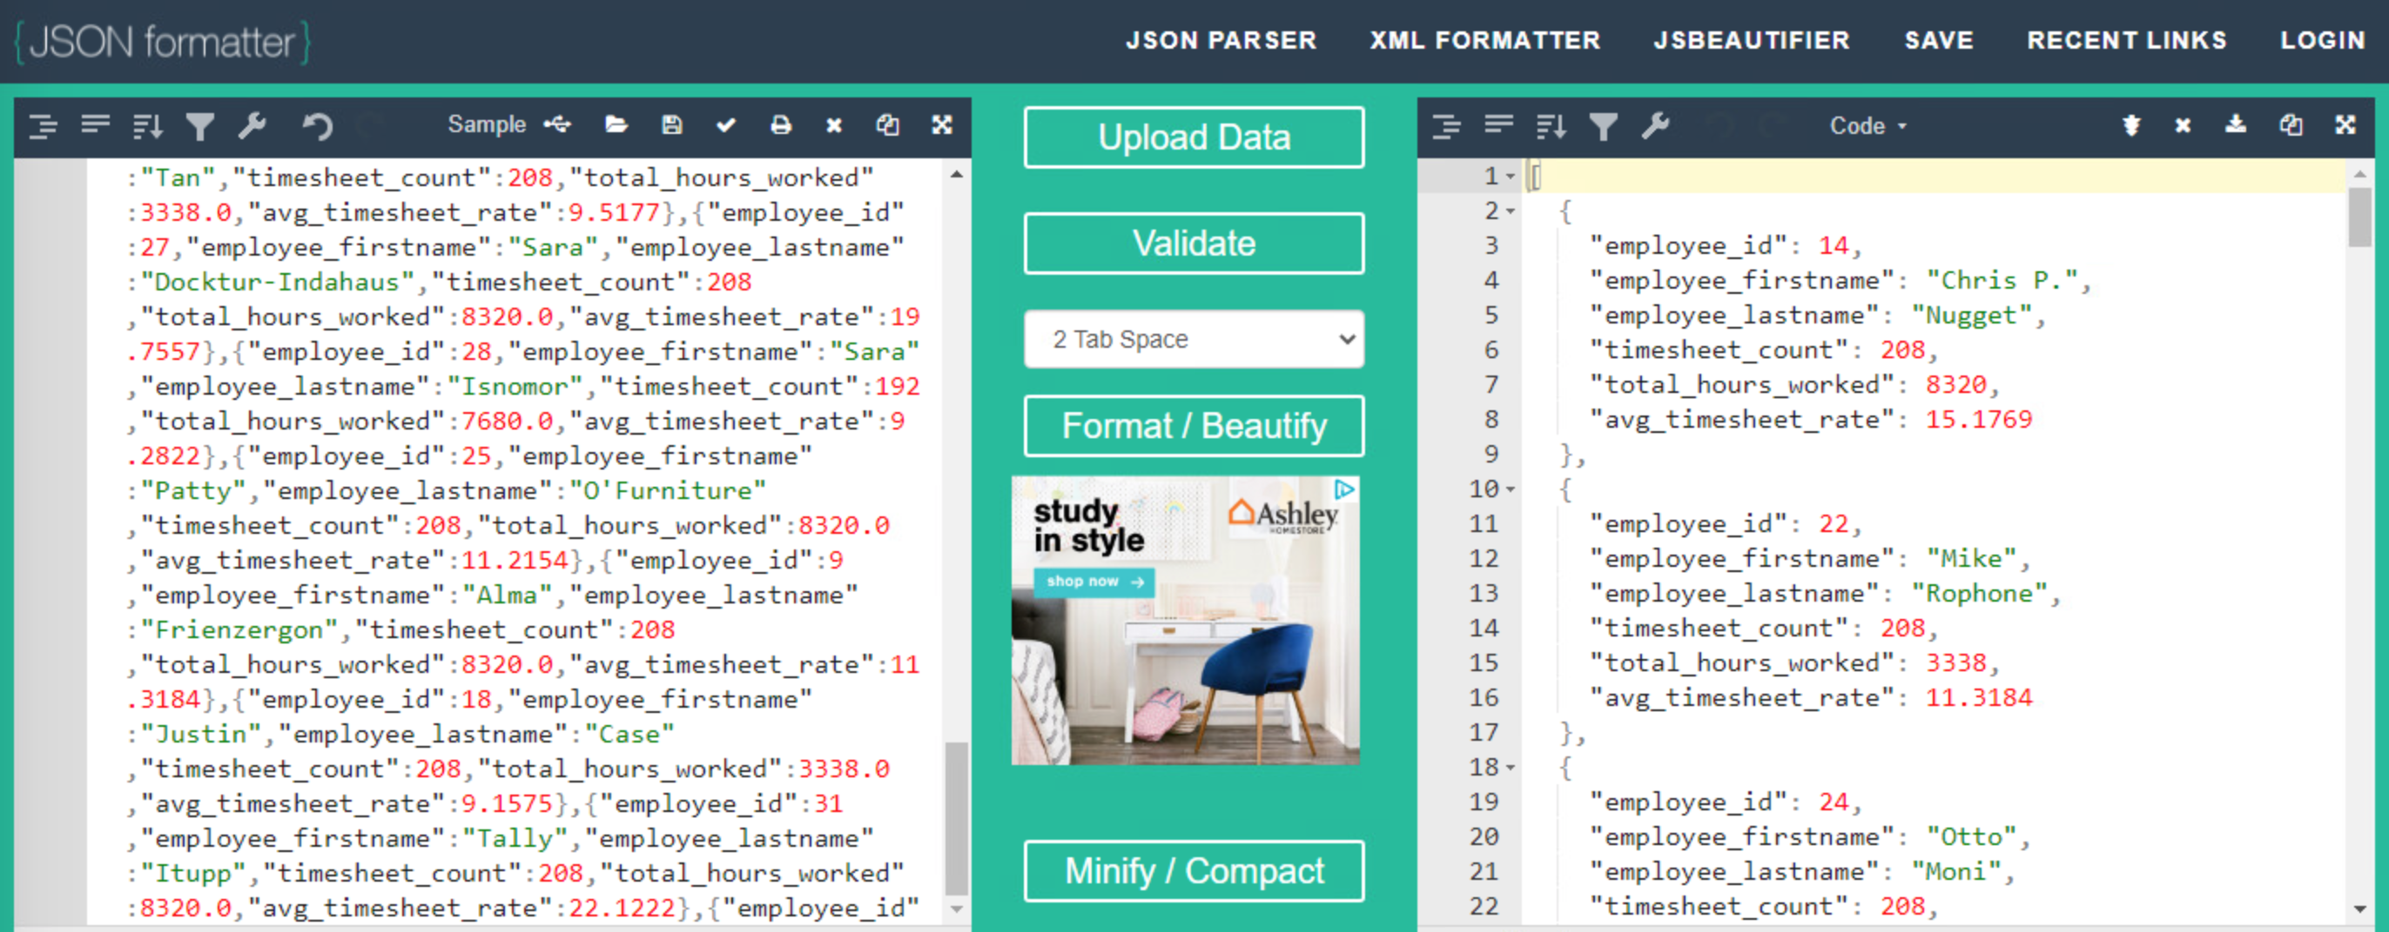

# **Appendix**

